ASSIGNMENT

Transistors in a CPU

A transistor is **a binary switch and the fundamental building block of computer circuitry**. Like a light switch on the wall, the transistor either prevents or allows current to flow through. A single modern CPU can have hundreds of millions or even billions of transistors.

Transistor in my intel i3 3217U - 1750 iMillionsIntel® Core™ i3-3217U Processor

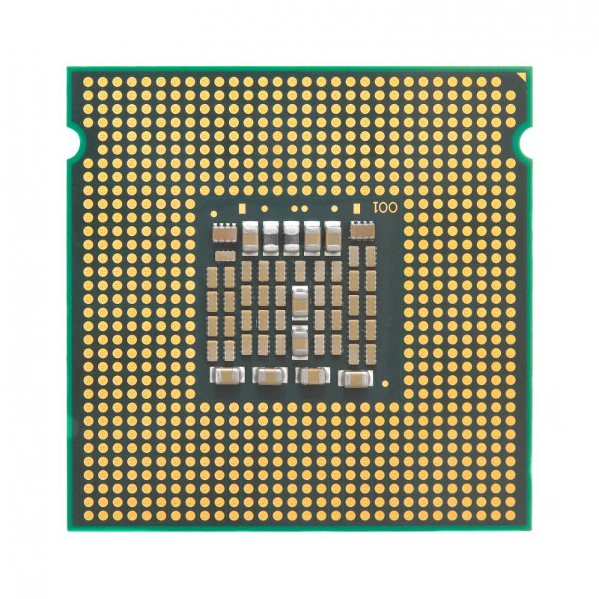

Check Computer's Performance

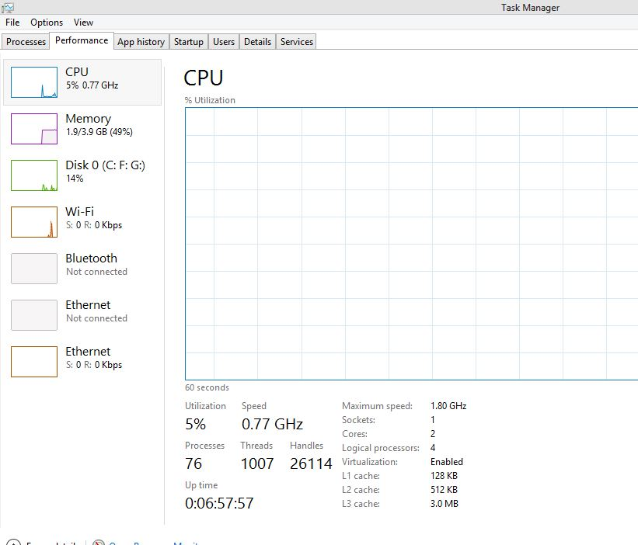

.

# What is an instruction set in a computer

An instruction is a set of codes that the computer processor can understand. The code is usually in 1s and 0s, or machine language. It contains instructions or tasks that control the movement of bits and bytes within the processor.

Example of some instruction sets −

* ADD − Add two numbers together.
* JUMP − Jump to the designated RAM address
* LOAD − Load information from RAM to the CPU.

## Types of Instruction Set

Generally, there are two types of instruction set used in computers.

### Reduced Instruction set Computer (RISC)

A number of computer designers recommended that computers use fewer instructions with simple constructs so that they can be executed much faster within the CPU without having to use memory as often. This type of computer is called a Reduced Instruction Set Computer.

### Characteristics of RISC

The characteristics of RISC are as follows −

* Relatively few instructions.
* Relatively few addressing modes.
* Memory access limited to load and store instructions.
* All operations done within the register of the CPU.

### Complex Instruction Set Computer (CISC)

CISC is a computer where a single instruction can perform numerous low-level operations like a load from memory and a store from memory, etc. The CISC attempts to minimise the number of instructions per program but at the cost of an increase in the number of cycles per instruction.

### 

### 

### 

### 

### 

### **Characteristics of CISC**

The characteristics of CISC are as follows −

* A large number of instructions typically from 100 to 250 instructions.
* Some instructions that perform specialized tasks and are used infrequently.
* A large variety of addressing modes- typically from 5 to 20 different modes.

## Types of Instruction

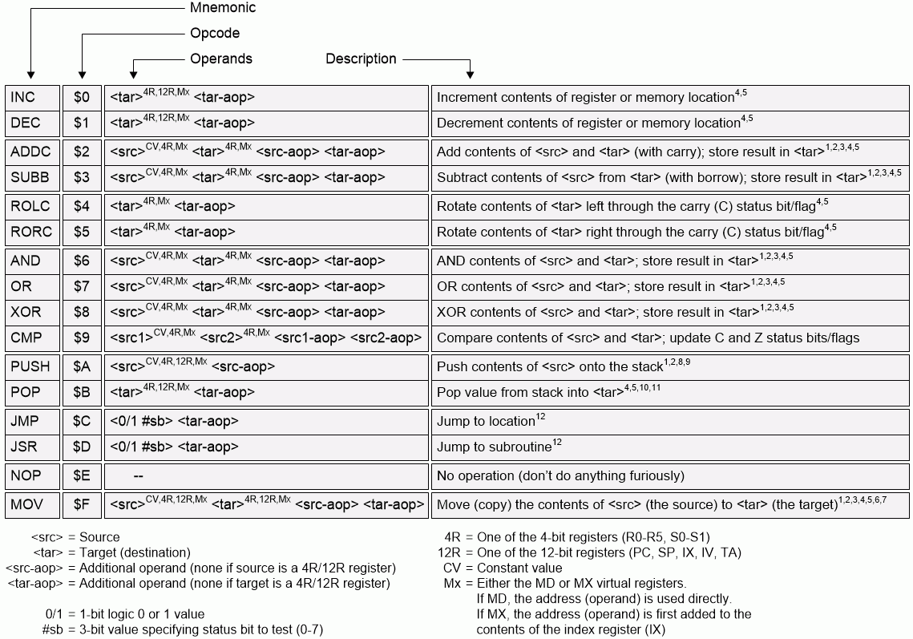

How many pins are in an i3 processo

It has contact patches on the CPU and sticks in the motherboard socket. This is called a Land Grid Array (LGA). If yours is an i3 it probably has 1150/1151/1155/1156 pins.

# Difference Between Analog And Digital Signal

# Difference Between Analog And Digital Signal

# Difference Between Analog And Digital Sign

# 

# 

# **Difference between Analog and digital**

# Analog and digital signals are the types of signals carrying information. The major difference between both signals is that the analog signals have continuous electrical signals, while digital signals have non-continuous electrical signals.

### **Analog Signal Graphs**

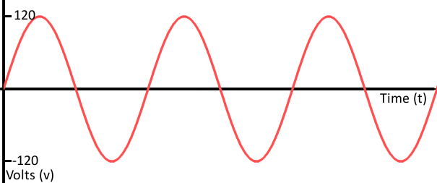

## **Digital Signals**

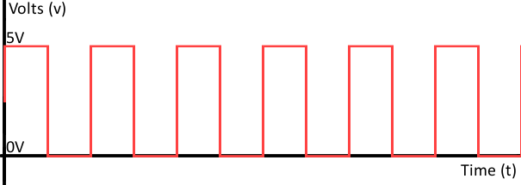

## **Flip Flop**

A flip flop is an electronic circuit with two stable states that can be used to store binary data. The stored data can be changed by applying varying inputs. Flip-flops and latches are fundamental building blocks of digital electronics systems used in computers, communications, and many other types of systems.

# 

# **Integrated circuit**

An integrated circuit (IC) is a small semiconductor-based electronic device consisting of fabricated transistors, resistors and capacitors. Integrated circuits are the building blocks of most electronic devices and equipment.

## **What Is Clock Speed**

The clock speed measures the number of cycles your CPU executes per second, measured in GHz (gigahertz).

A “cycle” is technically a pulse synchronised by an internal oscillator, but for our purposes, they’re a basic unit that helps understand a CPU’s speed. During each cycle, billions of transistors within the processor open and close.

A CPU with a clock speed of 3.2 GHz executes 3.2 billion cycles per second.

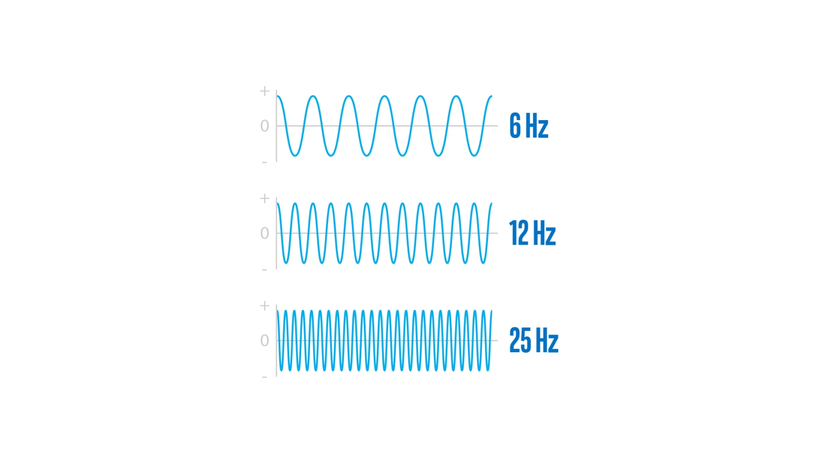

# Computer Organisation | Von Neumann architecture

Historically there have been 2 types of Computers:

1. **Fixed Program Computers –** Their function is very specific and they couldn’t be re-programmed, e.g. Calculators.
2. **Stored Program Computers –** These can be programmed to carry out many different tasks, applications are stored on them, hence the name.

The modern computers are based on a stored-program concept introduced by John Von Neumann. In this stored-program concept, programs and data are stored in a separate storage unit called memories and are treated the same. This novel idea meant that a computer built with this architecture would be much easier to reprogram.

The basic structure is like this,

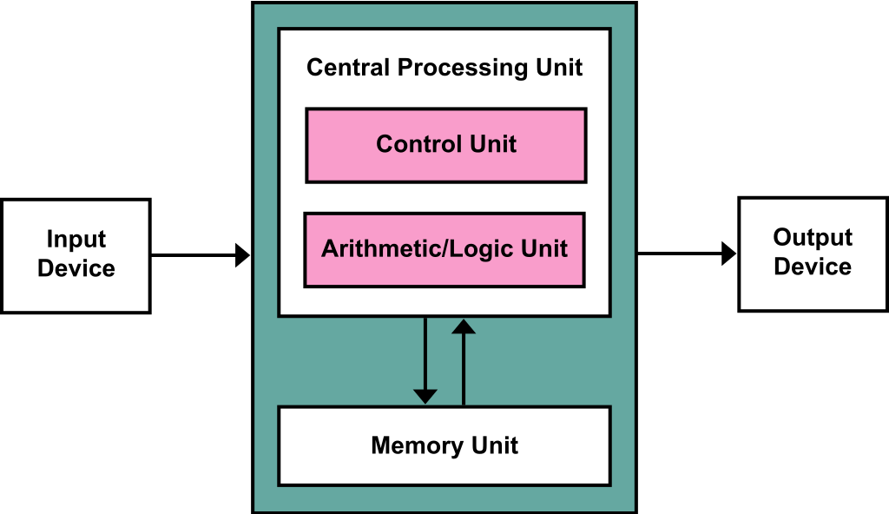

It is also known as **ISA** (Instruction set architecture) computer and is having three basic units:

1. The Central Processing Unit (CPU)
2. The Main Memory Unit
3. The Input/Output Device
4. **Control Unit –**   
   A control unit (CU) handles all processor control signals. It directs all input and output flow, fetches code for instructions, and controls how data moves around the system.
5. **Arithmetic and Logic Unit (ALU) –**   
   The arithmetic logic unit is that part of the CPU that handles all the calculations the CPU may need, e.g. Addition, Subtraction, Comparisons. It performs Logical Operations, Bit Shifting Operations, and Arithmetic operations.

### Registers

Registers refer to high-speed storage areas in the CPU. The data processed by the CPU are fetched from the registers.

# Bootstrap

A bootstrap program is the first code that is executed when the computer system is started. The entire operating system depends on the bootstrap program to work correctly as it loads the operating system.

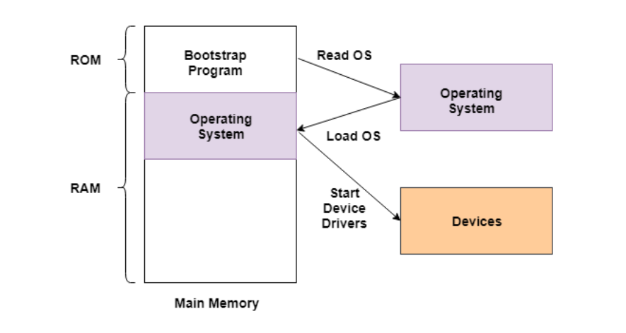

The booting procedure starts with the hardware procedures and then continues onto the software procedures that are stored in the main memory. The bootstrapping process involves self-tests, loading BIOS, configuration settings, hypervisor, operating system etc.

# Sams **Samsung Galaxy C7 Pro**

Details of my mobile -

### **Highlights**

* - 2.2GHz Snapdragon 626 Octa Core Processor
* - 4GB RAM With 64GB ROM

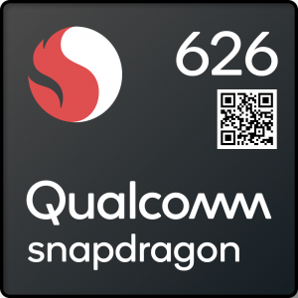

Architecture ARM

Microarchitecture ARM Cortex-A53

**Instruction set ARMv8 (64-bit)**

Some other instruction of ARM for snapdragon

ARMv6 , ARMv7, ARMv5,ARMv9

For MediaTek Helio P35

Instruction set ARMv8.2-A (64-bit)

MediaTek Helio G80

Instruction set ARMv8.2-A (64-bit)

# ng Galaxy C7 Pro

Links find by me to understand the topics-

Analog and digital link

<https://learn.sparkfun.com/tutorials/analog-vs-digital/all>

Flip flop link

<https://www.electronicsforu.com/technology-trends/learn-electronics/flip-flop-rs-jk-t-d>

IC link

<https://www.britannica.com/technology/integrated-circuit>

# Von-Neumann Model link

<https://www.javatpoint.com/von-neumann-model>

<https://www.tutorialspoint.com/what-is-an-instruction-set-in-a-computer>